There are 2 classes, Form and Person  
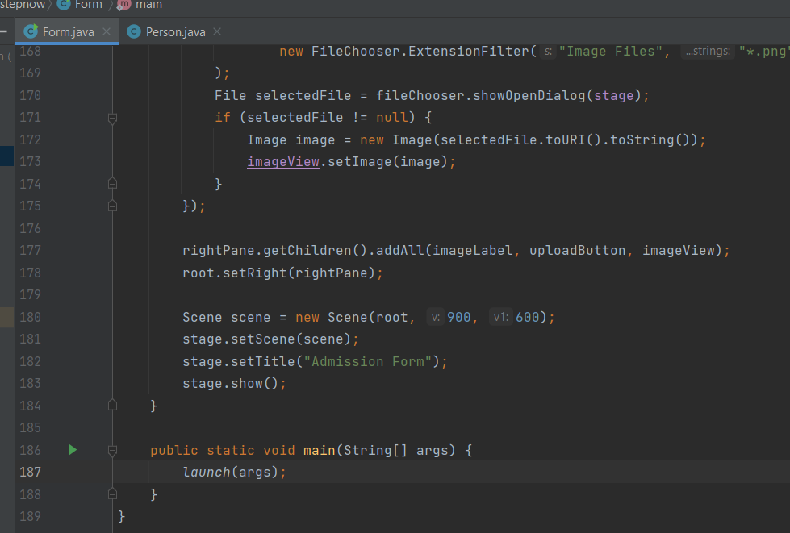

When we run the program, we get a welcome screen which asks us to Register or exit, if we select exit our program stops, if we Register then it proceeds to admission form:

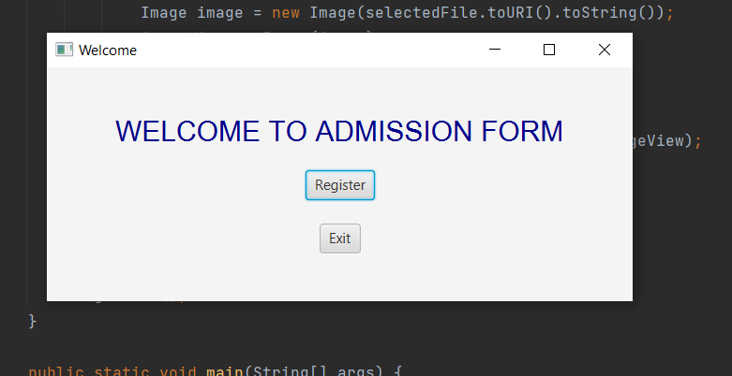

After clicking Register:

Fill the form:

By htting the save button, all the info is stored inside the arraylist of Person Type:

